**CSCI 3000 Homework 5**

**(Due: 10/30/2017)**

In this program, you will manage the information of employees in a company. You will read the **employees.txt** file and store every employee information in a class called **Employee**. You will have an array of Employee objects to keep the information of all employees.

The **employees.txt** file may be in different size. The first line of the file shows the number of employees in the file. And the rest of the file contains a single employee information in each line. A sample view of the file is given below:

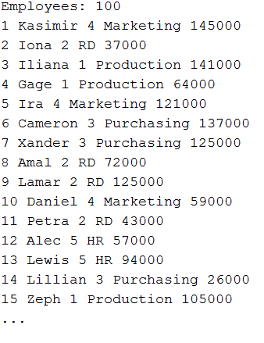

In your program you will read the first line and learn the number of employees. Then you will dynamically define an “Employee array” using dynamic memory allocation. Each employee has 5 information such as **Employee ID, Employee Name, Department ID, Department Name,** and **Salary**. Each information will be stored in a field in the Employee object. Once your employee array is ready, you will provide following operations to the user in a menu.

1. Print All Employees
   1. Print all information of all Employees
2. Print By Department
   1. Get an input from the user (department ID)
   2. Print all information only for employees in that department
3. Print By Salary
   1. Get a salary input from the user
   2. Print all employees that have equal or more annual salary to given input
4. Exit
   1. Exit from the program

As a bonus feature you can add following operations in the menu of your program

1. Print By Name (BONUS Option)
   1. Get a character from the user.
   2. Print only the employees whose name starts with that character.
2. Update Employee Information
   1. Get an Emp ID from the user.
   2. Ask which information to be updated.
   3. Update that information of the employee in the array.
   4. Update the file accordingly.

++++++++++++++++++++++++++++++++++++++++++++++++++++++++++++++++++++++++++++++

On the top of your source code, please add your name and number, Course ID, HW number and the date using a comment block. Please see the example below,

/*

Semih Dinc – MY_STUDENT_NUMBER

CSCI 3000, HW-X

(Due Date)

*/

Please do not copy your code from someone else’s program. The instructor may use a code comparison program that automatically checks the similarity between different programs. And do not hesitate to contact me if you are having trouble with the homework. I will be more than happy to help you to solve your problem.